Module 3: Key Support Functions for Insurer Success 1
Lesson 3: The Legal and Compliance Function 1
Learning Objectives 1
The Legal and Compliance Functions 2
Organization of Legal and Compliance 3
Responsibilities of the Legal Department 5
Responsibilities of the Compliance Department 10

Module 3: Key Support Functions for Insurer Success
Some functions primarily provide support to other functions. In this module, we’ll discuss three of the most important support functions that are essential to an insurance company’s success.
In this module, you’ll learn about
- How insurers use research and data to develop their marketing mix
- The process insurers use to create successful new products
- How the legal and compliance functions work together and separately to keep the insurer on the right side of the law

Lesson 3: The Legal and Compliance Function

An insurer must comply with an increasing number of laws and regulations in carrying out its business. In addition, insurers need advice and representation related to legal disputes, corporate transactions, and other issues. Learn how legal and compliance carry out their related, but separate responsibilities.

Learning Objectives

- Distinguish between the legal and compliance functions, and describe the roles and responsibilities of each area.
- Describe the primary responsibilities of the legal department.
- Describe the primary responsibilities of the compliance department.
- Explain the difference between solvency laws and market conduct laws, and explain several market conduct laws that insurers must comply with.
- Describe the purpose of a market conduct examination and how the compliance department is involved in market conduct examinations.
- Distinguish between two types of market conduct examinations in the United States.

The Legal and Compliance Functions
Learning Objective
Distinguish between the legal and compliance functions, and describe the roles and responsibilities of each area.

You probably noticed that the marketing and product development lessons contained a lot of talk about regulations:
- Product approval
- Required disclosure forms
- Ads approval
But how do insurers know if they're following the rules and doing things the right way? Legal and compliance play a big role. These functions sound the same, but they're not.

Organization of Legal and Compliance
Insurance companies typically have a legal department, also known as a law department, to handle issues related to law. In some companies, the legal department handles both legal and compliance functions. Smaller companies that operate in fewer jurisdictions are more likely to use this type of organizational structure.
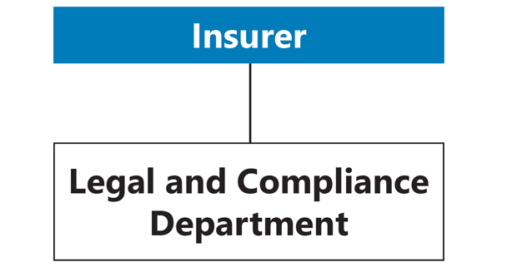
Larger insurance companies are more likely to maintain separate legal and compliance departments. Yet even small companies sometimes separate the legal function from the compliance function organizationally to emphasize the importance of compliance and to ensure the independence of the compliance function.
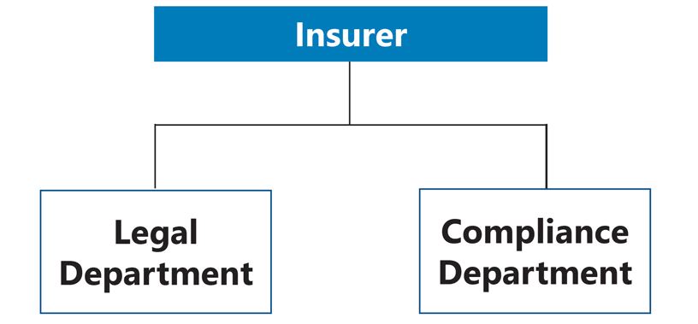
Other insurers, typically very large insurers, may establish a compliance department responsible for ensuring corporate compliance with laws and regulations, but still delegate responsibility for each division's compliance to compliance personnel in that division. For example, a company that is organized by product line might delegate compliance responsibility to individuals in each of the company's product lines.
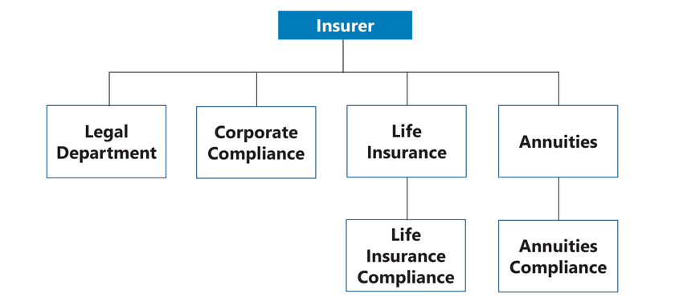
Generally, the person in charge of an insurance company's legal department is known as the general counsel or chief counsel. The general counsel usually reports directly to the company's CEO and advises the company's board of directors on important legal issues affecting the company. Attorneys and other legal department staff report to the general counsel.
In some companies, the general counsel is also the company's chief compliance officer. The chief compliance officer (CCO) is responsible for overseeing and managing the company's compliance with regulatory requirements and internal policies and procedures. If compliance activities are part of the legal department's duties, the general counsel also manages the compliance managers and specialists. If the CCO is a separate position from the general counsel, the chief compliance officer may report to the general counsel or to the CEO.

Responsibilities of the Legal Department
Learning Objective
Describe the primary responsibilities of the legal department.

Which of the following activities do you think the legal department of an insurer would be involved in? Choose all that apply.
Incorporation, Licensing, and Corporate Changes
Insurance laws in the United States and Canada typically require that insurers be organized as corporations. As a corporation, an insurer can be a party in a legal action, enter into contracts, and own property. Click or touch each heading below to learn more.
Domestic Corporations
The jurisdiction in which an insurer incorporates, or forms the corporation, is known as its domicile, and the insurer is known as a domestic corporation of that jurisdiction.
Once incorporated, the company's legal department must obtain a certificate of authority, or license, which is a document that grants the insurer legal authority to conduct an insurance business in the specified jurisdiction. As a general rule, most jurisdictions require insurance companies and insurance financial professionals to be licensed by or registered with a specific regulatory agency before conducting business in that jurisdiction.
An insurer can sell only the products or services authorized by its certificate of authority or license. If a company's board of directors decides to expand into additional product lines or jurisdictions, the legal department oversees the application process for additional licenses.

Multinational Corporations
A corporation that operates in more than one country—known as a multinational corporation—faces unique legal issues in that it must comply with the laws of its country of domicile and also the laws and regulations of each country in which it conducts business. The legal department advises the board of directors on the best way to enter into business in a foreign market.
The legal department also handles many aspects involved in expanding or reducing operations. For example, an insurance company can expand operations by acquiring or merging with another company. In an acquisition, one company gains ownership control by buying most or all of the other company's stock or assets. In a merger, a company agrees to unite with another company to form a new company. In both cases, the companies can gain access to additional products, customers, distributors, and markets.
On the other hand, an insurer may decide to sell blocks of business or spin off a company to exit a line or lines of business. For example, a company preferring to exit the individual life insurance market could sell its block of individual life insurance policies through assumption reinsurance to another insurer. The company could also separate from one of its divisions or a company that it owns through a spinoff. The independent company created in the spinoff would own the original company's individual life insurance business. The legal department would be involved in these transactions as well.
Watch this animation for a summary of the corporate transactions we have discussed in this section.
In addition, the legal department is available to advise the board of directors on any number of issues that arise during the course of the company's operations. For example, the board may want the legal department to review a contract with a foreign company to ensure that it doesn't violate any trade agreements before the contract is signed.
Representing the Insurer in Legal Proceedings
At times, a person or organization may initiate a legal proceeding, known as a lawsuit, against a life insurance company, or an insurer may institute a lawsuit against another person or organization. For example, insurers deny a small percentage of life insurance claims for reasons such as the policy was not in force at the time of the insured's death, the deceased was not covered under the policy, or the cause of death was excluded from the insurance coverage. If a policyowner or beneficiary disputes an insurer's decision to deny a claim for benefits, the insurer's claim department, in conjunction with the legal department, works with the claimant to settle the dispute. If the dispute cannot be settled, and a lawsuit is filed, the legal department oversees the litigation process.

A lawsuit is an action brought before a court of law by a party claiming that they have been harmed in some way by another party. The process or act of presenting the dispute to a court of law for a resolution is known as litigation. In such situations, the legal department represents the insurer, or arranges for an independent law firm, often known as outside counsel, to represent the insurer in the litigation process. If the company chooses outside counsel for representation, the insurer's legal department communicates with and oversees the outside counsel. Attorneys who handle litigation for an insurance company, whether company employees or outside counsel, are responsible for
- Initiating or responding to a lawsuit
- Researching the facts of a case
- Taking statements and depositions from involved parties
- Consulting with company employees before they testify in court
- Researching relevant court cases
- Hiring expert testimony, if needed
- Representing the insurer in all aspects of the litigation process, including correspondence and court appearances
Litigation can be time consuming and costly. Additionally, a public trial can result in negative publicity that may harm the company's image. For these reasons, the legal department typically tries to settle legal disputes without going to court if at all possible. Formal or informal negotiations to resolve the dispute are known as alternative dispute resolution (ADR) methods. Two common methods of ADR are mediation and arbitration. Click or touch in the boxes below to learn more.

Mediation

Mediation is a process in which an impartial third party, known as a mediator, facilitates negotiations between the parties in an effort to create a mutually agreeable resolution of the dispute.
If the parties cannot resolve their dispute through mediation, they typically have the right to go to arbitration or to continue with litigation.

Arbitration

Arbitration is a process in which an impartial third party, known as an arbitrator, evaluates the facts in the dispute and renders a decision that usually is binding on the parties.
An appeal of an arbitrator's decision is generally possible only if the arbitration was done improperly.

Working with Internal Functions
The legal department interacts with and provides support to every internal function within an insurance company. Some of the legal department's specific responsibilities include the following (click or touch the right arrows below to learn more).

Human Resources

Advises on employment laws, particularly those related to employee rights, benefits, and nondiscrimination in employment practices.

Responsibilities of the Compliance Department
Learning Objectives
Describe the primary responsibilities of the compliance department.
Explain the difference between solvency laws and market conduct laws, and describe various laws that insurers must comply with.

Why is compliance important for an insurer? An insurer that fails to comply with a law or regulation may suffer significant financial consequences. Which of the following consequences can occur when an insurer is found to not be in compliance with applicable laws and regulations? Choose all that apply.

The compliance department, in conjunction with the legal department, monitors all applicable laws and regulations, communicates compliance requirements to employees through policies and procedures, and makes sure that company employees are following the company's established policies and procedures. Actions of the compliance department may include
- Disseminating regulatory information to employees
- Overseeing the licensing, training, and conduct of financial professionals
- Approving advertisements and sales literature
- Protecting customer privacy and confidentiality
- Coordinating internal and external audits
- Coordinating market conduct examinations
- Working with regulatory agencies to demonstrate the company's compliance with applicable laws
- Managing a fraud prevention unit
In the United States, the states are the primary regulators of insurance; and they have insurance laws designed to protect the public trust. These laws can be divided into two general types. Click or touch in the boxes below to learn more.

Solvency Laws

Solvency laws ensure that insurers are financially able to meet their debts and pay policy benefits as they come due.

Market Conduct Laws

Market conduct laws ensure that insurers conduct business fairly and ethically.

Employees who handle an insurer's financial matters generally manage solvency compliance. Compliance department employees generally are responsible for ensuring that the company complies with market conduct laws.
Areas of State Market Conduct Compliance
Market conduct requirements seek to ensure that insurance companies treat policyowners fairly with respect to marketing and sales practices, policy provisions, claim handling, and customer service. In the United States, market conduct laws are often based on model regulations proposed by the National Association of Insurance Commissioners (NAIC), a private, nonprofit association that promotes uniformity of state insurance regulation. Click or touch each heading below to learn about areas with which insurers in the U.S. need to comply with state laws.
Product Development
Advertising
Financial Professionals and Sales Activities
Underwriting Practices
Claims Practices
Complaint Handling
Privacy
Electronic Signatures, Contracts, and Documents
Cybersecurity
Insurance Fraud
Federal Regulation of Insurance

While the states have primary authority for regulating insurance, insurers are also subject to federal regulation. Here are a few of the areas governed by federal laws with which insurers must comply:
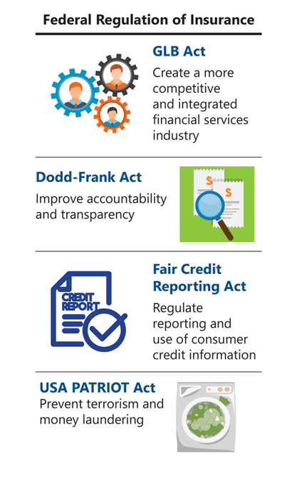
Functional Regulation
The Gramm-Leach-Bliley (GLB) Act permits financial firms to affiliate in ways that result in a more competitive and integrated financial services industry. In addition, the GLB Act requires companies to maintain policies to safeguard the security and confidentiality of customer information and requires states to have uniform or reciprocal insurance agent licensing laws.
Accountability and Consumer Protection
The Dodd-Frank Wall Street Reform and Consumer Protection Act (Dodd-Frank Act) is a U.S. federal law that improves accountability and transparency in the financial services system and protects consumers from abusive practices.
Use of Consumer Credit Information
The Fair Credit Reporting Act is a U.S. federal law that regulates the reporting and use of consumer credit information. It seeks to ensure that consumer credit reports contain only accurate, relevant, and current information.
Terrorism and Money Laundering
The USA PATRIOT Act is a federal law designed to prevent, detect, and prosecute terrorism and international money laundering. According to the act, U.S. insurers that sell products that can be used to launder money, such as individual permanent life insurance, individual annuities, and individual products that have a cash value or investment feature, must have an anti-money-laundering program.
Regulation of Securities
The U.S. federal government has the primary authority to regulate the securities industry. Examples of securities include stocks, bonds, mutual funds, variable life insurance, and variable annuities. Federal securities laws provide a framework that includes registration requirements; regulation of the purchase and sale of publicly traded securities; reporting and filing requirements; and dispute resolution requirements, periodic examinations of registered entities and individuals, and the right to take action against those who violate laws. The Securities and Exchange Commission (SEC) is the federal agency responsible for administering federal securities laws.
Regulatory Compliance Management Programs
Most insurers establish regulatory compliance management programs that focus on prevention, education and training, and monitoring. Although we present these three initiatives individually here, they overlap in many ways and ideally are integrated throughout business processes.

Prevention
To have a successful regulatory compliance management program, management must commit to an ethical work environment. Compliance and ethics are related concepts. A company that operates within a framework of integrity and ethical values also maintains a culture of compliance. Use the right arrows below for examples of a culture of compliance.

The company has in place hiring practices that reinforce the company's commitment to compliance.
In a culture of organizational compliance, every employee views compliance as his own responsibility.
For a regulatory compliance management program to be effective, compliance personnel must be knowledgeable about the regulatory requirements of all jurisdictions in which the company operates. Personnel must also continually monitor the regulatory environment for changes that might impact insurer operations. If the right policies and procedures are in place, and if employees follow these policies and procedures, then problems with noncompliance are significantly reduced or eliminated.
Finally, an insurer must establish internal control systems that can assess how well employees are adhering to the company's compliance policies and procedures. Internal controls may be as simple as establishing a procedure for a compliance officer to sign off on marketing materials before they are used, or as complex as installing a computer program that can detect confidential information in an employee's email.
Education and Training
To be effective, a regulatory compliance management program must educate employees about the laws and regulations relevant to their work activities. For example, in the United States, state insurance laws describe the minimum information that insurers must maintain in their complaint records and place specific requirements on the way insurers handle customer complaints. Just recording a customer's complaint isn't enough to satisfy these laws. Customer service representatives and any other employees who are likely to receive customer complaints must be trained in a company's complaint handling procedures. In addition, all company employees must be aware of and understand the company's policies and procedures for complying with these laws, so that they do not inadvertently violate a law.
Much market conduct legislation applies to the insurance sales process. Because insurers are generally held responsible for the actions of their financial professionals, insurers spend a significant amount of time and money training financial professionals in compliance issues.

Many companies provide their employees and financial professionals with compliance manuals containing information about the company's compliance programs and the market conduct rules they must follow. Ideally, such manuals provide employees with specific examples of compliance and noncompliance so that employees can better identify compliance risks in their day-to-day work activities. In addition, a regulatory compliance manual must be updated as regulatory requirements change, and such changes should be clearly communicated to employees.
Here, an expert explains the role that compliance plays in training financial professionals.
Monitoring
An insurer's regulatory compliance management program must include monitoring. Why? To ensure that the company (1) responds quickly to issues before they become bigger problems, (2) identifies training needs of employees, and (3) improves the quality of compliance procedures.

A common way to monitor compliance is through auditing. An internal audit is an examination of a company's records, policies, and procedures that is conducted by a person who works for the insurer, typically in the compliance area. An internal audit examines a specified area of a company's operations rather than the entire company. The results of an internal audit are reported directly to the audit committee of the insurer's board of directors.
Audits conducted by parties not associated with the insurance company are called external audits or independent audits. Insurance laws in many countries require external audits of an insurer's market conduct.

Market Conduct Examinations
Learning Objectives
Describe the purpose of a market conduct examination and how the compliance department is involved in market conduct examinations.
Distinguish between two types of market conduct examinations in the United States.
Periodically, in the United States, insurance regulators conduct examinations of the operations of life insurance companies. A market conduct examination is a formal investigation of an insurer by one or more state insurance departments. The purpose of the market conduct examination is to determine whether the insurer's market conduct—its nonfinancial operations—is in compliance with applicable laws and regulations.
There are two types of market conduct examinations. See if you can figure out which kind is described below.
hrght examining all nonfinancial aspects of its operations.
Some state insurance departments periodically examine each insurer licensed by the state. For example, a state may examine all insurers operating within the state every two to three years. Other states conduct examinations when they identify specific complaints about an insurer's market conduct activities or have a specific concern about an insurer's operations.
One of the primary roles of the NAIC is to advise state insurance regulators on the most effective and efficient methods for overseeing the market conduct of insurance companies. The NAIC encourages multistate examinations as a way for state insurance departments to share costs. However, states reserve the right to independently conduct their own reviews.

Both target and comprehensive examinations are designed to ensure that the
- insurer has standards in place for the activity being examined
- insurer's standards comply with applicable regulatory requirements
- activity being examined is carried out according to established standards
State laws require that insurers maintain various business records for a specified time and allow examiners to review these business records as well as other documents. Market conduct examiners also want to know whether an insurer has established an internal audit plan by which it can detect and correct compliance problems.
Market conduct examiners review the insurer's audit plan and audit reports, as well as all accompanying procedures manuals. Market conduct examiners review how management uses the information in an audit report. For example, does management respond to recommendations in an audit report by adopting new procedures or modifying existing procedures?
Most market conduct examinations today are target examinations that examine one or more lines of business or specific areas of an insurer's nonfinancial operations, such as its advertising materials. Target examinations are conducted whenever an insurance department thinks them necessary, and often result from customer complaints or recent changes in applicable regulations.
What Happens After the Completion of a Market Conduct Exam

Examiners provide a report of their findings.

The report may include an order detailing actions the insurer must take to correct compliance problems.

If it has disagreements with the report, the insurer may request a hearing.

After the hearing, the hearing officer may make changes to the report.

The state insurance department adopts the finalized examination report, places it on file, publishes it on its website, and provides a copy to the NAIC.

If necessary, the state insurance department sanctions the insurer and/or imposes a compliance action plan.

The insurer may be required to provide periodic evidence of compliance with any order contained in the report.
The more you understand what legal and compliance do, the better you'll be at avoiding potential legal liability for your company. Remember, compliance isn't just a function within your company: it's every employee's responsibility.

